**User table**

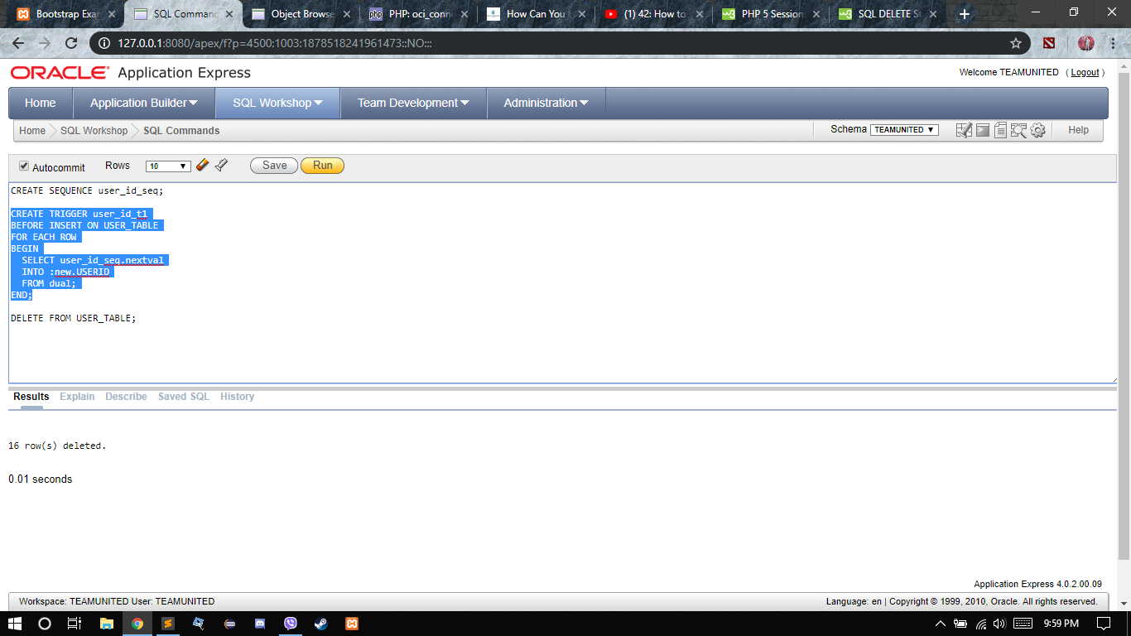

User table created in oracle for user with the attributes userid, firstname, lastname, email, password, username, and making userid as the primary key.

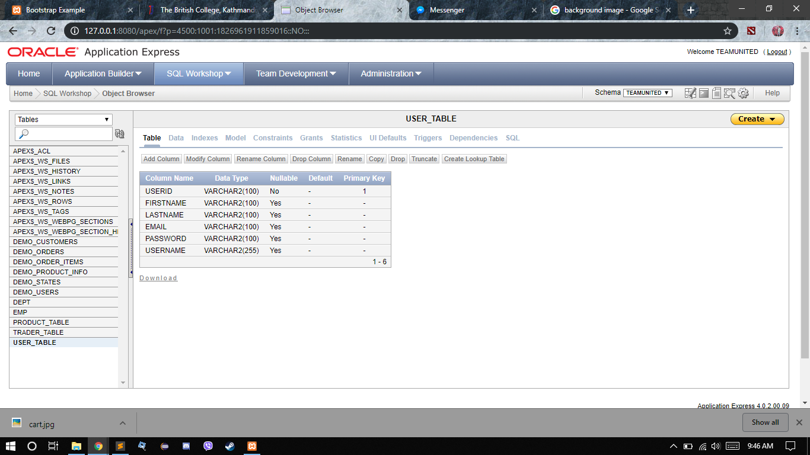

User table created